**Name: Victoria Jacqueline Macias Pico**

**W O R K S H E E T S**

**NOTE:** **Your answers must be in blue and bold.**

# UNIT 7

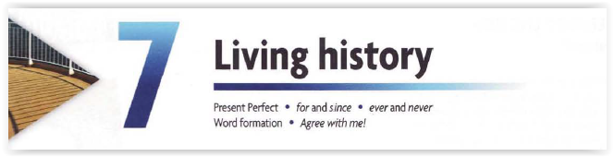

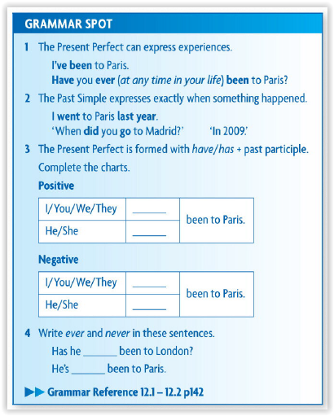

**Have**

**Has**

**Haven´t**

**Hasn´t**

**ever**

**never**

**REVIEW**

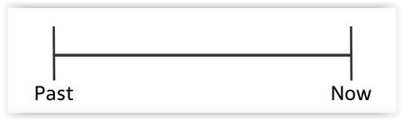

**1. Write the PAST PARTICIPLE of the following verbs:**

|  |  |  |  |  |  |  |  |
| --- | --- | --- | --- | --- | --- | --- | --- |
| **be** | **Been** | **drive** | **Driven** | **fly** | **Flown** | **see** | **Seen** |
| **begin** | **Begun** | **eat** | **Eaten** | **go** | **Gone** | **shake** | **Shaken** |
| **Blow** | **Blow** | **fall** | **Fallen** | **hide** | **Hidden** | **speak** | **Spoken** |
| **break** | **Broken** | **forget** | **Forgotten** | **knows** | **Known** | **steal** | **Stole** |
| **choose** | **Choosen** | **forgive** | **Forgiven** | **lose** | **Lost** | **swim** | **Swun** |
| **do** | **Done** | **get** | **Got or gotten** | **ride** | **Ridden** | **take** | **Taken** |
| **dream** | **Dreamed** | **give** | **Given** | **ring** | **Rung** | **write** | **Written** |

**QUIZLET**

<https://quizlet.com/4430836/english-past-participle-quiz-flash-cards/>

<https://quizlet.com/335389945/english-irregular-verbs-flash-cards/>

<https://quizlet.com/_8b64cg?x=1jqt&i=1ax7a2>

**2. Change the verb into the correct form:**

1. I have read (read) your book several times.
2. She has worn (wear) that skirt many times.
3. My family has visited (visit) Brazil a few times.
4. I have already eaten (eat) already.
5. Marta has finished (finish) her homework.
6. You have broken (break) the glass again.
7. They have paid (pay) for everything.
8. It has never snow (never snow) like that.
9. I have met (meet) Anna once.
10. The kids have grown (grow) so much!

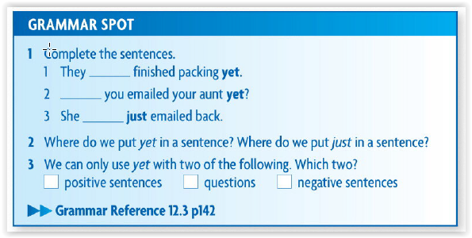

**Haven´t**

**Have**

**Has**

**Write the sentences with the correct form of the verb in Present Perfect. And, place the adverbs 'yet', 'just' and 'already' in the correct order.**

|  |  |
| --- | --- |
|  | **SENTENCE** |
| 1. She / already / know / all her neighbours in a week | She already know all her neighbours in a week |
| 1. The postman / arrive / yet? | Has the postman arrived yet? |
| 1. You / have breakfast / yet? | Have you had breakfast yet? |
| 1. My son / go / already / to bed | My son has gone already to bed |
| 1. I / not be / yet / in your new house | I haven´t been in your new house yet |
| 1. He / have just / a shower | He has just had a shower |
| 1. The programme / not start / yet | The programme hasn´t start yet |
| 1. We / watch already / that film twice | We have already watch that film twice |

**For or since**

|  |  |
| --- | --- |
| **QUESTIONS** | **ANSWERS** |
| What do you do? | I am learning english. I also really like listening to music and reading in english |
| Since when do you do that? | I have always done it in my free time |
| For how long? | I listen to music for long hours. I learn and read for an hour. |

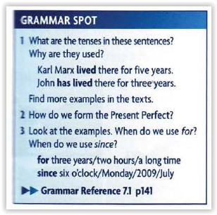



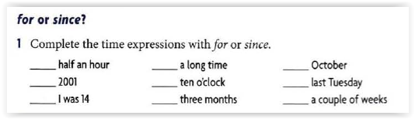

**Since For**

**Since Since**

**For**

**Since**

**For**

**Since**

**Since**

**For**

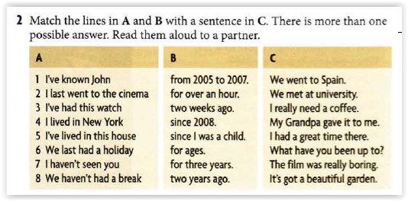

|  |  |  |  |
| --- | --- | --- | --- |
|  | **A** | **B** | **C** |
|  | I´ve known John | Since 2008 | We met at university |
|  | I last went to the cinema | For over an hour | The film was really boring |
|  | I´ve had this wacth | For three years | My grandpa gave it to me |
|  | I lived in new york | For ages | I had a great time there |
|  | I´ve lived in this house | from 2005 to 2007 | it´s got a beautiful garden |
|  | We last had a holiday | Two years ago | We went to Spain |
|  | I haven´t seen you | Since I was a child | What have you been up to? |
|  | We haven´t had a break | two weeks ago | I really need a coffee |